Supporting your child with spelling difficulties at home

Which words does your child need to learn to spell?

Try the first 100 high frequency words
https://www.highfrequencywords.org/hfw100fp.pdf

Look at the spelling lists in the National Curriculum English – Spelling Appendix
https://assets.publishing.service.gov.uk/government/uploads/system/uploads/attachment_data/file/239784/English_Appendix_1_-_Spelling.pdf

Practise spelling words in lots of different ways:
Say the letter names if the word is irregular e.g. said
Say the sounds or syllables if the word is a regular phonic word e.g. boat is b-oa-t or fan/tas/tic
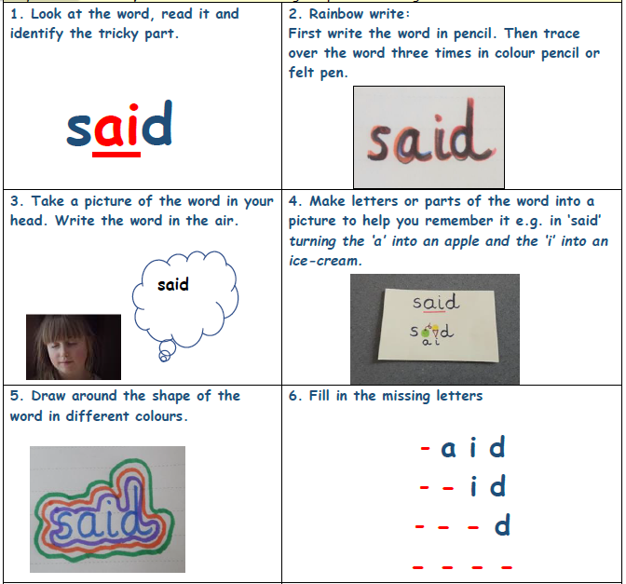

Try out these websites and apps:

For a whole printable spelling pack you can print off:
SNIP Spelling (Written by specialist teachers – there are 4 levels of programmes available free to print off and use).
http://www.snip-newsletter.co.uk/pdfs/downloads/literacy_programme_1.pdf

SqueeblesSP- app for IPAD or Android which cost approximately £2.99.
You can make tests for your child, if you know the spellings they are working on or access ready-made tests. Use the same word test daily for a week. Different words can be worked on the following week.

SqueeblesWS – an app for IPAD or Android which costs approximately £3.50
You can make personalised word searches very quickly and easily using the spellings your child is learning. Alternatively use the ready-made ones on the app.

BBC Bitesize Crystal Explorers: KS2
https://www.bbc.co.uk/bitesize/topics/zkbkf4j/articles/zbm8scw
Play an intrepid explorer on an adventure through five fantastic maze worlds. Collect the crystal shards as you go, unlocking the challenges and using your knowledge of grammar, punctuation and spelling to solve the fiendish puzzles.

Worksheet Genius
www.worksheet.genius.com/english_worksheets
Create free spelling activity worksheets using your child’s target spellings e.g. Anagrams, Look-Cover-Write-Check, Word search or Sentence Building.

Phonics Play
www.phonicsplay.co.uk – currently free to all users during school closure period without a subscription. Offers lots of phonic games across Phases 1-6, printable worksheets and advice to parents about phonics. To support spelling specifically, choose the segmenting games.

