Attention and Listening pack (For families)
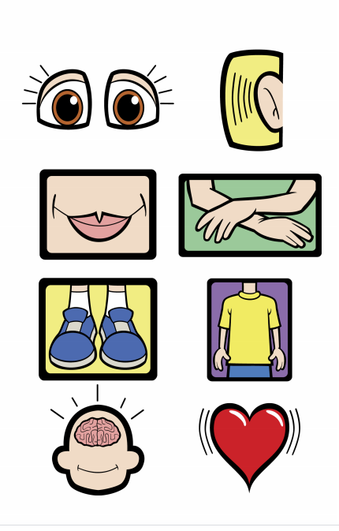
Source: Whole Body Listening Larry at School! (Sautter and Wilson, 2016)

Contents

Description | Page number
Background/evidence | 3
Attention and Listening - ages and stages | 4-5
Strategies to support attention and listening | 6-7
Visual resources in the home | 8-15
Whole body listening/Listening Larry (Sautter and Wilson, 2016) | 16-17
General games to develop attention and listening skills | 18-28
References and Resources | 29

Background/evidence
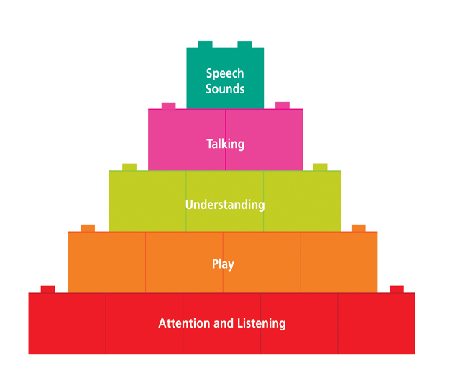
Source: https://www.thecommunicationtrust.org.uk

What are listening and attention skills? Why are they important?
• Listening and hearing are not the same; we hear all sorts of noises but choose those we “tune in” (listen) to. Children need to learn to filter out distractions such as background noise in order to focus on the main speaker.
• Listening is key to effective communication and is an active process. In order to be an effective listener, children need to learn to monitor their own understanding.
• Attention is necessary in most daily activities as it enables individuals to focus on the task being undertaken.
• Children’s attention can be variable according to their motivation to the task and the task requirements. For example, children may be able to hold a conversation whilst playing with building blocks but need to focus entirely when reading a book.

Attention and Listening – ages and stages
(Cooper, Moodley and Reynell, 1978)
Whilst the norms provide a developmental age, it is important to consider that children’s skills develop at different rates. It should be noted that different activities require different levels of attention and listening skill.
Stage 1: (0-12 months)
- Can pay fleeting attention, though highly distractible
- Attention is held by dominant stimulus in the environment e.g. someone walking
- Turns to sound of door banging, or to mum talking

- Look for what motivates the child and incorporate it into the activity
Stage 2: (12-24 months)
- Rigid attention to his/her own choice of activity
- Inflexible attention to a concrete task of his/her own choice. Cannot tolerate adult attempts to modify task.
- Does not look up when name is called. Will look if touched as called

- Gain the child’s attention first by calling their name
- Now and Next boards can help shift focus
Stage 3: (2-3 Years)
- Single channel attention: Can attend to adult’s choice of activity if under adult control
- Can shift attention from an instruction, then back to the task as long as an adult helps transfer attention
- Will look up from puzzle if chin is touched, and then back to puzzle when pointed at.

- Call the child’s name and wait for them to look before speaking
- Praise child for looking

Stage 4: (3-4 Years)
- Single channelled attention: under child’s control
- Child needs to give full attention, visual and auditory, to instructions, but doesn’t need adult help to do this
- Can listen and then do something, but only one thing at a time

- Call the child’s name and wait for them to look before speaking
- Tell them when it is time to listen

Stage 5: (4-5 Years)
- Integrated attention - for short spells
- Two-channelled attention. Child can take verbal direction without needing to interrupt the task and look up. Ready for class teaching.
- Can listen to instructions whilst looking down at a book

- Be aware of how long you are expecting children to listen for
- Praise them for good listening

Stage 6 (6 Years +)
- Integrated attention
- Can maintain integrated attention for a longer period of time, as necessary to concentrate adequately in the classroom
- Will stay at an activity without reminders

- Continue to build in learning breaks with changes in activity

It is important to consult relevant professionals e.g. Occupational Therapists for functional impacts of attention and listening on learning e.g. sensory factors. Also, if you suspect that your child has a more severe difficulty e.g. Attention Deficit Disorder consult a paediatrician for more support.

General strategies and to support with home learning
- Sit near your child and make frequent eye contact to help keep them focused
- If possible, sit your child where there are few distractions such as away from windows, computer screens, background noise etc.
- Get your child’s attention before beginning to talk – you can tap a board/clap/ring a bell etc. as a signal that you are waiting for them to show their “good listening skills” or use their name before you start talking
- Consider making the “good listening skills” into a poster for your child to refer to.
- Praise and give positive feedback to your child when he is showing “good listening skills” e.g. “George, I can see that you are nodding while I am talking, so I can tell that you are listening”
- Remember to use an appropriate level of language e.g. short, simple sentences, rephrasing information.
- Check that the information has been understood ask your child to explain what he has to do, make sure he knows when the task is complete, if necessary show your child what to do rather than repeating lots of language.
- Use visual support such as pictures, objects, practical demonstration, gestures, YouTube clips while you are talking as children find it easier to concentrate on visual things.
  - Write down step by step what you want your child to do – and ask them to tick off each step as they do it. This helps keep your child focused as well as helping them remember what they have to do
  - Use a Now-Next board increasing to a First, Next and Then board with a motivating activity that your child can look forward to and know when it will be happening.
  - Use a visual timetable for your child’s day, so that they know the structure of the day and whereabouts they are up to (you can have ready made visual timetables with pre-prepared visuals of activities or you can have a go at drawing and writing what is coming next).
  - Use timers or sand timers which increase in time so that the children can have a visual, auditory reminder of how long they need to attend before a break/motivator.
  - Use reward charts as a visual representation for good listening with a suitable motivator after X number of episodes of good attention, increasing or decreasing the number of episodes before they receive the award depending on how easy they are finding attending. Remember, it’s important for the child to have some ‘wins’ for good attention to keep motivated to attend.

- Take turns; get the child to be the teacher.
- Work for short periods of time.
- Include movement breaks where necessary

Visual resources in the home

Visual supports put in place at home are designed to help your child to:
- plan ahead for events that do not fit into his usual routine
- follow an adult led routine
- develop his social skills, eg, participating in group activities with peers

This could include:
- a daily timetable
- within-task schedules
- Countdown board - “Three more night-nights until…”
- egg timers

Below is a description of each support and ways these can be used with your child.

Daily timetable
Set this up every day for your child to refer to. Using this you can introduce slight differences from week to week (eg “free play” can become “park”) to help him accept changes to routine which sometimes cannot be avoided. In the morning show your child the timetable, point to each symbol and say what will happen. For example:

Wash
Breakfast
Play-group
Home
Lunch
Free play
iPad
Tea
TV
Bed time

“Today we are going to wash, have breakfast, go to playgroup… and then bedtime. Now it’s time to wash”.
- After each activity get your child to take the symbol off and put it in a plastic pocket or box, then point to the next symbol saying “now it’s time for …”.
- For activities when your child isn’t home take those symbols off yourself and when he gets home just show him the next symbol saying “now it’s time for …”.

book
posting
puzzle

choosing
Within-task schedule
Place each activity you want him to carry out down the left hand side (green). When each activity is completed tell your child, eg, “Puzzle is finished, take the symbol off and move it over. Now it’s time for reading”.
This can be used for specific tasks with more than one step in them, such as:
- “Play with mummy” time - you could choose four activities you want him to complete with you, eg, puzzle, reading, posting, choosing
- Going out if you are visiting several places, eg, park, a friend’s house, Tesco, home.

Countdown board
When you want to help your child prepare for changes to his usual schedule use the countdown board. Place the activity symbol on the bottom Velcro strip and the three “sleep” symbols above it. This visual support can be used for events such as visiting grandparents or friends.

Egg timer
Use an egg timer to help your child move from one activity to the next. You may want him to carry out an activity for only 5 minutes or you can introduce the timer 5 minutes before you want him to finish an activity. Eg, when he is using the iPad give him a 5 minute warning and show him the timer. When the timer is finished show him the timer and say “iPad is finished, it’s time for …”

Now and Next board

Next
Now
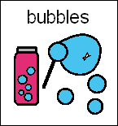
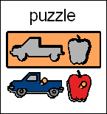

A Now/Next Board is a mini-schedule that is portable and can be used to show what your child is going to do in a short time span, for example one might be a picture of a puzzle that you would like your child to do and the other might be of a treat that she can have after she has completed the puzzle, such as bubbles.
Decide which task you would like the child to do first and place a picture under the NOW (left) section of the board. To begin with you should make the task a little easier for your child i.e. pick an easy puzzle or expect her only to put in 1 or 2 pieces (as the rest have already been done).
For the NEXT (right) side of the card, the child might choose a preferred activity to engage in for a short period of time or you could select something that your child will enjoy or appreciate. The activity on the right should be rewarding and exciting for the child so that they have something to look forward to.
Once the pictures are on the board, talk through the schedule with your child – as you talk about the pictures help your child to touch the picture you are talking about, “Now puzzle and next bubbles”.
After you have talked through the schedule, take the schedule with you to the first activity. Again draw your child’s attention to the picture by removing it from the board and showing it to her alongside the activity. Place the picture back onto the board until you have finished the activity.
Once she has finished the activity, help your child to remove the card and say something like “puzzle has finished” then place the picture into a bag or finished box.
After this help your child to point to the NEXT picture and say something like “next it’s bubbles”. Reward your child by doing the motivating activity in the NEXT box!



Symbols for use with Now and Next board and visual timetables

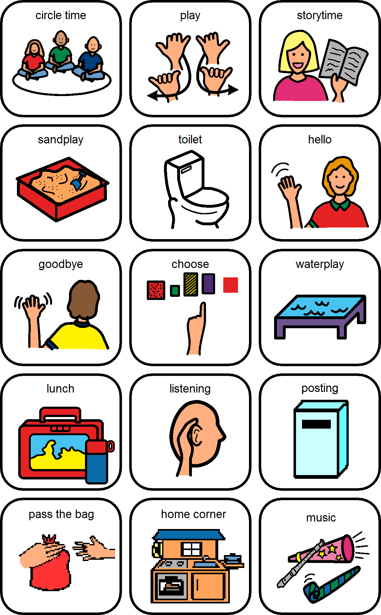

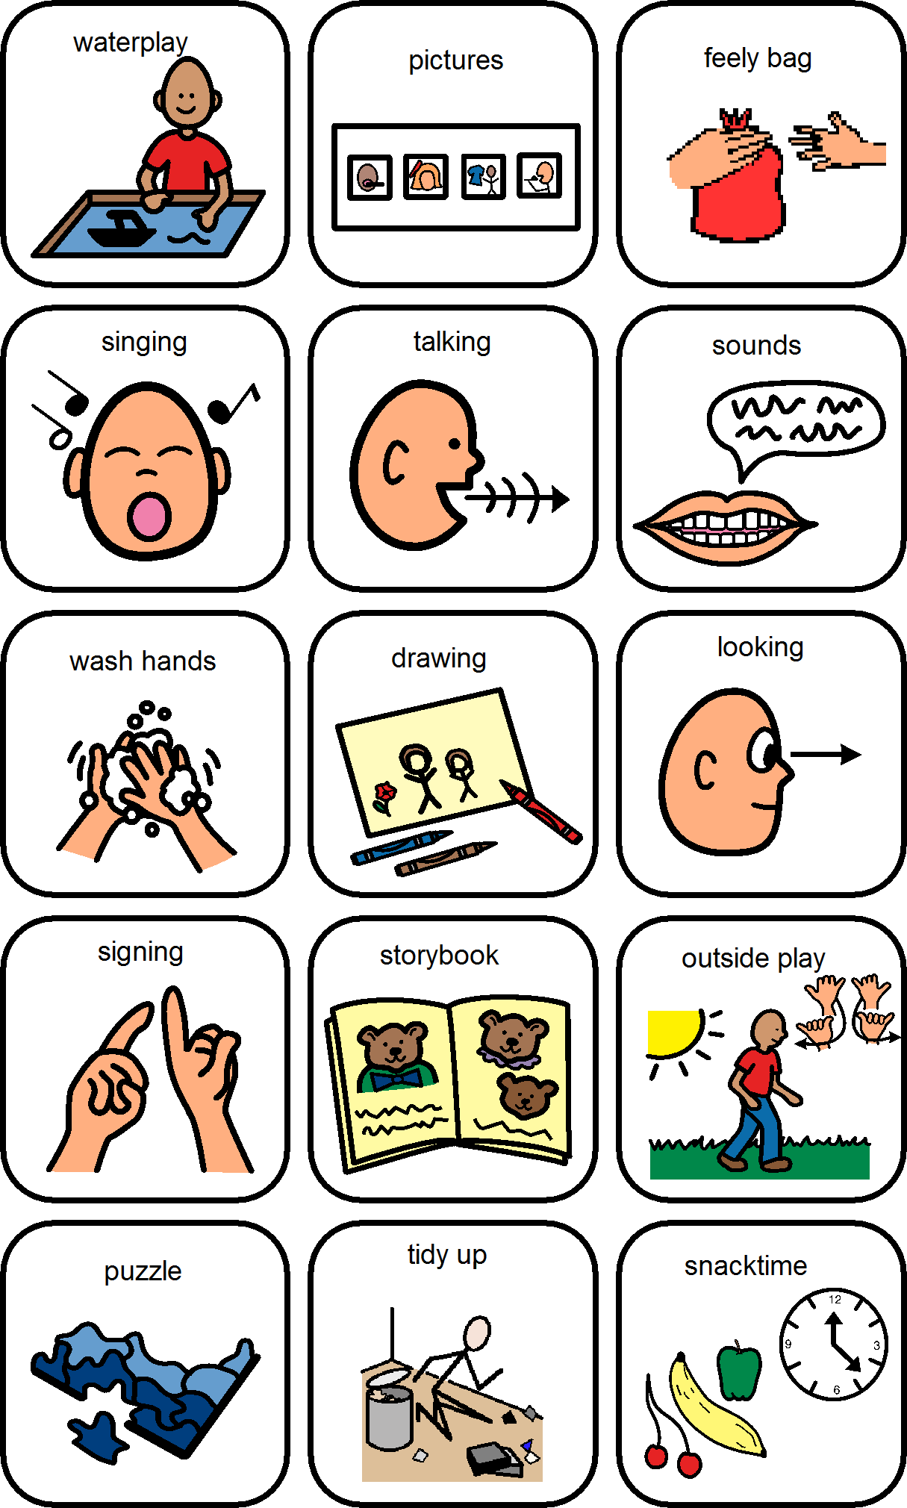

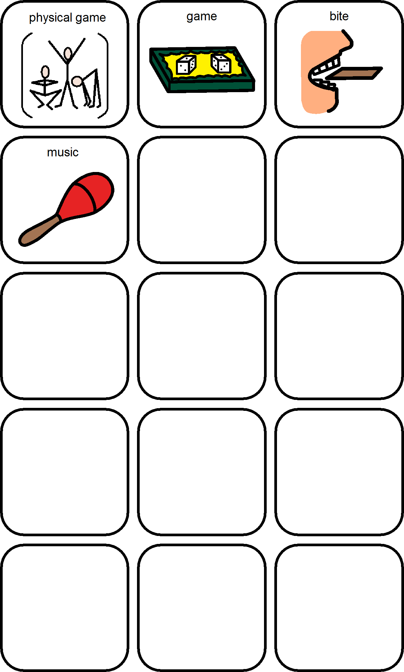

Whole body listening/Listening Larry (Sautter and Wilson, 2016)
Whole body listening teaches children to understand that we listen with more than our ears and makes implicit expectations about what it means to "listen" more explicit.
Whole Body Listening is:
- listening with the eyes (looking toward the speaker)
- listening with the ears (both ears ready to hear)
- listening with the mouth (quiet and waiting for your turn to talk)
- listening with the hands (quiet and kept to yourself)
- listening with the feet (quiet and still)
- listening with the body (facing toward speaker)
- listening with the brain (thinking about what is being said)
- listening with the heart (considering the speaker and others listening)
Source: https://www.socialthinking.com/Products/whole-body-listening-larry-at-school-2nd-edition

Activities that you can do with Listening Larry
- Introduce the principles of Whole Body Listening to the child going through each of the aspects e.g. good looking and model them visually, get the child to practice each of the components of good listening with you.

- At another time, tell the child that you are going to make some mistakes with Listening Larry and the child needs to tell you what you need to do better e.g. looking round the room, or tapping your fingers on the desk.

- Use Larry with verbal and visual prompts when you see that the child is not doing something e.g. put the brain visual in front of the child if you see that he is thinking/talking about something that is not to do with the session. Gradually fade out the verbal prompts and see if the child can self-correct with just the visual of the area of Whole Body Listening that they are finding difficult at that time.

- With older children you can reflect about what you and they might find difficult about Listening Larry e.g. you can say that you find doing ‘good listening’ difficult sometimes and keep the ‘ear’ symbol in front of you. See if they can reflect on any areas that they might find difficult and keep the visual in front as a reminder.

- With older children you can illustrate how the different components of Whole Body Listening work together, e.g. you can say that when a child stops doing good looking (turning the looking symbol face down) then it can mean that they stop listening (turning the listening symbol face down) and then that can mean that they stop doing good thinking (turning the thinking face down) but….when they start doing good looking again (turning the looking symbol face up) then it means that they start listening better (turning the listening symbol face up) and so on.
Note: For children who have difficulties keeping their hands or feet still, or have sensory needs which impact on their ability to look or listen please consult an Occupational Therapist for more guidance on supports e.g. fiddle toys. For more information on guidance from our Occupational Therapy team on Attention and Listening, please see the following link https://www.buckshealthcare.nhs.uk/childrenandyoungpeoplesot/resources.htm
Attention and Listening Activities

These activities can be used as a quick warm up to your session, to help get your child’s attention and listening skills focused. Remember to praise your child when they have demonstrated good attention and listening as soon as you see it!

Many activities have been taken from Developing Baseline Communication Skills (1999) Delamain and Spring.
- “Molly Says….” (rather like Simon Says!)
This activity can support: Listening skills; Develop vocabulary (any words introduced in the task, especially verbs)
For younger children, you will need: Puppet/soft toy
Activity: Introduce the children to the puppet and explain that he/she is going to tell them what to do, but they have to listen carefully.
Start with simple instructions` Molly says touch your nose,’ Molly says clap your hands’.
To make the task harder you can:
- Increase the length of instructions (see Information Carrying Word pack for help with appropriate numbers of information-carrying words)

- Single out individual children in the instructions, so they have to listen for their name. This can be useful if you think children are following the crowd rather than listening themselves.

- If a child is having difficulty, or only carries out part of the instruction, repeat the instruction whilst the children are carrying it out, so they can hear it in context: “That’s right, Molly said to dance in a circle”.

For older children substitute using a puppet for yourself!

- Find the Noise
This will help to develop: Listening skills, Vocabulary (e.g. loud, find, ring etc.)
You will need: An item with an alarm that you can set e.g. clock, mobile phone, oven timer or something that ticks loudly.
Activity: This activity needs careful timing, so the alarm goes off at the appropriate time! Explain to the children that you have hidden something noisy in the room and they have to find it.
Nominate a child to go first and see if they can find their way to the alarm. Hide the item in a different place each time. It might help to have an accomplice to hide or activate the alarm! Obviously, it might be a good idea to get the children to close their eyes! Once the children have the idea, you could ask the child who found the item to hide it for the next child. Continue until all the children have had a turn.
To make this activity harder:
- Make the sound intermittent rather than continuous
- Make the sound quieter

- Feely Bag

This activity will help:
Attention and listening skills; Develop new vocabulary (talking about different aspects of objects (i.e. what to do with it, what it feels/looks like, verbs involved with the object); helps children strengthen their memory for new words and helps give them strategies for storing and retrieving words in future; Learn turn-taking skills; Encourage multi-sensory play
Feely bag
You will need: Pairs of everyday objects which are familiar to children e.g. two toothbrushes, two spoons etc, A bag
Activity:
Show the children the objects, and talk about each one and what it is used for
Show the children that one of each pair is going into the bag.
Let each child feel in the bag and try to identify without looking which object they can feel, and either name or point to the corresponding item. If they struggle, show the child a little bit of the object in the bag, without taking it out.

- Parts of the Body
This activity will help:
Learn new words; Develop listening skills; Turn-taking skills; Vocabulary: stickers, names of stickers
You will need:
Large doll; 2 different types of stickers
Activity: Introduce the doll to the children e.g. a large puppet type doll (Mollie the Dolly). She is big enough to put your hands inside her hands and is very lifelike! She lives in a pillowcase and I tell the children I have bought my friend to meet them, she sits on my lap and waves and says hello to each child.
After the introductions, introduce the stickers making sure the children can identify them.
Ask each child in turn to come and take a sticker (a good fine motor activity), and place on a named part of the doll’s body (The number of pieces of information in the instruction depends upon the child’s developmental level, i.e. they may not be ready to retain more than one piece of information. If this is the case, you can split the instruction up into two parts: ‘find the appropriate sticker’ and ‘put it on dolly’s nose’)

You could finish the session with an action song about parts of the body e.g. Heads, shoulders, knees and toes.

- I went shopping and bought….

This activity supports attention and listening and auditory memory skills too. Start the activity saying ‘I went shopping and I bought…an apple. The next person says, ‘I went shopping and I bought an apple and…some bread…’ and so on continually adding a new item to the list. You can accompany your words with gestures to provide a visual support to help your child’s memory. It does not always have to involve food, it can be about anything e.g. ‘I went to the farm and I saw….’
See the Resources section on page 25 for more activities to support Auditory and Working memory in children.

- Bingo
You can use self-made bingo boards or ready-made boards e.g. boards from Twinkl. This can be used with vocabulary that the child is familiar with or with new vocabulary that you are wanting to teach. It’s good to have a picture and the word in the Bingo game if possible if teaching new vocabulary to support learning and to make the game more eye catching.

- Feeding the Animals
This activity will help:
Develop listening skills; Develop understanding; Learn new words (Vocabulary: names of animals, and food)
You will need: Boxes (start with 2), with cut-out animal faces and mouths cut out to enable feeding, plus a selection of food (pictures or real food!) e.g. apple/carrot slices, biscuits, crisps etc.
Activity: Let the children identify the animal cut-outs and the food.
Ask each child in turn to e.g. ‘give the frog an apple (2 information carrying words)’.
If the children are confident with this instruction, ask them to either give 2 items of food to 1 animal (3 information carrying words), or give 2 animals an item of food each (4 information-carry words). For more information on information-carrying words, see pack regarding information carrying word instructions for more information.

- Listening treasure box
Collect lots of things that make a noise, such as: Crinkly paper, Noise-making toys, Pots and pans, Musical instruments Books with noise buttons Explore! Listen and talk about them.

- Mystery sounds
Equipment: a whistle, a cup and spoon, a bunch of keys, a packet of crisps, a tin containing rice, one or two musical instruments
Let the children investigate the objects and listen to the sounds made by the rustling crisp packet etc.
Children then sit with their back to you or to each other. The noisemakers are placed on a table or on the floor in the centre of the circle. One child comes and chooses which noise to make, his pair tries to guess what the sound is.

- Guess the instrument
To be able to identify a musical instrument from its sound.
Equipment: Box of instruments
Barrier
Pairs of instruments
Give the children plenty of opportunity to handle and experiment with the musical instruments before trying this game.
Select 3 pairs of instruments which sound different from each other.
Give the child one set and take the second set.
Place the screen or barrier between yourself and the child. Explain that you are going to play one of the instruments and the child is to guess which one it was. He can demonstrate by playing his matching instrument. Raise the screen and let him see whether he was right or wrong.
Make the game harder by including more pairs of instruments and instruments that sound more similar to each other.

- Spot the mistake
Sing a simple rhyme or song, but make a mistake – can children spot the mistake? Incy wincey spider climbing up... a tree (should be spout) The wheels on the... train go round and round (should be bus) Twinkle twinkle little... hat (should be star)

- You got it wrong
To be able to detect deliberate mistakes in a story.
Any short storybook with which the children are familiar.
The children are seated in a semi-circle in front of you. Explain that you are going to read them a story (tell them its name e.g. Little Red riding hood) but you think you may be going to make some mistakes. Can they help you put it right? If they spot a mistake, they should shout stop! You got it wrong! And you choose someone to tell you what was wrong.
One day Little Blue Riding hood was sent by her mother to take some goodies to her grandfather. Little Red Riding Hat set off through the woods. It was a lovely day and she dawdled along the way to pick up some poisonous toadstools which she put in her basket. Little Red Riding Hood didn’t know that following behind her, hiding behind the trees was the wicked tiger.
Why is it important? Some children will require more specific individualised intervention and strategies to access the classroom. For some children, whose attention is not yet under their own control, this area of development may need to be a priority and require more specialist support.
Some of the wider language related factors that affect children’s attention and listening, and may be important to consider, are:

- Go games - wait for go
Build a tower of bricks. Your child waits for you to say “Go” before they can knock it down. Have a race – ready steady go... Push a car to each other – ready steady go... Dance around – ready steady go... Roll the ball – ready steady go...
Go game (2)
Children seated in a circle. Explain that you are going to tell them things to do but they must only do that when they hear the command go.
Shut your eyes – go
Open your eyes – go
Put one hand up – go
Put the other hand up – go
Put both hands down – go
Touch your nose – go
Increase the length of time between giving the instruction and saying ‘go’ to 4, 5 or 6 seconds.
You can use a drum, triangle or whistle to give the signal and make the signal quieter and quieter.

- Hunt the sound
Tape recorder or other continuous noise source.
Hide the sound source under one of the boxes in the room while children close their eyes. One child is chosen to locate the sound source.
Increase the number of boxes and make the children stand some way away from them and point to the source of the sound.

- Where am I?
To be able to locate the source of quiet and/or intermittent sounds
Equipment: Sound makers which can play without needing mains leads (battery operated radio or tape recorder, mobile phone, wind up or battery-operated musical toy).
Explain to the children that you are going to play a hide and seek game. Tell them what they will be listening for. They must be very quiet and listen carefully. Whoever finds the hidden sound maker must stand still and put his hand up. Tell the children to cover their eyes and hide the sound maker somewhere around the room. The children open their eyes and walk or tiptoe quietly round, listening for the sound. After the sound maker has been found, repeat using a different hiding place.
Make it harder by using something with an intermittent sound.

- Musical bumps
Play music and when the music stops the child has to sit down on the floor. The slowest person will be out. The last one is the winner.

- Musical statues
Play music and when the music stops the child has to stand as still as a statue. The slowest person will be out or the person who moves the first is out. The last one to move is the winner.
You play an instrument and the child(ren) have to copy by walking either loudly e.g. marching if you play the instrument loudly or tip toe if you play the instrument softly. Change roles. You can use the metaphor of elephants or butterflies if that helps.

- Mousie-Mousie
To detect a specific sound among other sounds and react quickly.
Equipment: commercial game Mousie Mousie, or a set of six toy rubber mice with long tails, a plastic cup big enough to cover the mouse body, a mat or piece of cloth.
This game is suitable for a maximum of 6 children. The children are in a small group round a table. Each child is given a mouse. The first child to have a turn places his mouse on the mat or cloth and takes hold of the end of its tail. Explain that you are the cat and when he hears you give a meow, you are going to try and catch him by popping the plastic cup over his mouse. His job is to pull the mouse out of the way the moment he hears the meow, you will be making lots of other animal noises but he must wait until he hears the meow and only then pull his mouse clear.
This is an extremely useful game for working with letter sounds. Instead of a meow, choose a sound that is being worked on in literacy. Tell the children what sound they are looking for e.g. ssssss. Tell the child that you will be making lots of other letter sounds but today, ‘ssss’ is the dangerous sound and they must move their mouse out of the way when they hear that sound.

- Fruit Salad
To be able to listen to your identity as one of a group and remember it.
The children are divided into small groups of 4 or 5. Each member of the group is allocated a fruit e.g. apple, pear, banana, pineapple, strawberry.
You stand in front of the group.
When you say two fruits e.g. pear and banana, they will need to swap places. When you say fruit salad, everyone needs to swap places.

- Count the bears
To be able to listen for and respond to specific words
Counters and a small container for each child.
Explain that you are going to say a list of animal names. Every time they hear the word ‘bear’ they are going to put a counter in their pot or container.
Call out animal names one at a time, including ‘dog, cat, bear, hippopotamus, bear, elephant, cow, mouse, frog, bear, bird, bear, snake, guinea pig, camel, bear, giraffe’ (so 5 bears in total. Tell the children that they should have 5 counters in their pot. 5 counters = good listening.
Repeat with a new list, this time containing a different number of bears.
Extension: Speed it up, put the animal names into short phrases e.g. a black dog, a flying beard, a bear in the zoo, a teddy bear.

- Zoo game
To be able to listen to cues and maintain attention for 5 minutes
Tell the children to sit on chairs or mats in a circle around you with enough room outside the circle for the children to run around. Explain that you are going to tell a story about a class going on a visit to the zoo. When the child hears his own name mentioned in the story, he must get up and run once around the outside of the circle. When the word ‘zoo’ is heard, the whole class must get up and run around in the same direction. Best played with a maximum of 10 so that each child can have several turns. It allows you to spot children whose attention is wandering and bring his name into the story immediately. As the story progresses, more than one child can be named at a time.

Example:
Mrs Smith’s class was going on a coach trip to the zoo (everyone should get up and run around the circle). The coach driver sorted out who was going to sit at the back. Melanie got on first (Melanie gets up and runs around). Katie wanted to sit next to her, so she got on next. Darren wanted to be by a window – and so did Kevin. When they were all sitting down with their seat belts done up, the coach set off for the zoo. Sally had brought some sweets, so she handed them round. John and David had learnt a new song, so they taught it to the others. It was a long drive and Daniel, George and Alice got bored. But at 11 o clock the coach arrived at the zoo. (And so on, until the concentration span of the group is exhausted).

- Finders keepers
To be able to listen to an instruction and wait to carry it out until told.
Pencil and paper for the adult to note down what each child has been told to find.
The children sit in a circle. Explain that each child will be told to go and find a certain item in the room. They must wait until everyone has been told what to find before they move. You will say ‘now’ to tell them when to start. When they have found their object, they must return to the circle and sit down. Each child is named in turn and told to find an everyday object (‘Christopher you will find a red crayon, Susie will you find a pot of glue’. When the whole group has been given an object to find say ‘Now’ and the hunt begins.
Children known to have short concentration spans or poor memories should be among the last to be given their instructions.

References and Resources

- Developing Baseline Communication Skills (The Good Communication Pathway) Paperback – 1 Jan. 1999 by Catherine Delamain (Author), Jill Spring (Author)

- Speaking, Listening and Understanding: Games for Young Children (The Good Communication Pathway) Paperback – 26 Jun. 2003 by Catherine Delamain (Author), Jill Spring (Author)

- Whole body listening/Listening Larry (Sautter and Wilson, 2016)

- Zones of Regulation – this is a means of using colour to help children develop an awareness of their emotions and energy states and can be an additional tool to support attention, listening and learning. For more information you can access our very own Zones of Regulation pack by contacting the number below or for more in depth information, visit their webpage at https://www.zonesofregulation.com/learn-more-about-the-zones.html

- For more information on guidance from our Occupational Therapy team on supporting Attention and Listening, please see the following link https://www.buckshealthcare.nhs.uk/childrenandyoungpeoplesot/resources.htm

Supporting Auditory and Verbal memory

For resources regarding supporting memory skills the following may be useful.
https://www.blacksheeppress.co.uk/product/auditory-memory-2nd-edition/
https://www.blacksheeppress.co.uk/product/developing-auditory-and-verbal-memory-skills/
Contact: Any queries contact CYP Therapies on 01296 566045

