Social Stories

What are social stories?
Social stories were created by Carol Gray in 1991. They are short descriptions of a particular situation, event or activity, which include specific information about what to expect in that situation and why.
The terms 'social story' and 'social stories' are trademarks originated and owned by Carol Gray.

What are social stories for?
Social stories can be used to:
- Develop self-care skills (e.g. how to clean teeth, wash hands or get dressed), social skills (e.g. sharing, asking for help, saying thank you, interrupting) and academic abilities.
- Help someone to understand how others might behave or respond in a particular situation.
- Help others understand the perspective of a person with autism and why they may respond or behave in a particular way.
- Help a person to cope with changes to routine and unexpected or distressing events (e.g. absence of teacher, moving house, thunderstorms)
- Help provide positive feedback to a person about an area of strength or achievement in order to develop self-esteem.
- Used as a behavioural strategy (e.g. what to do when angry, how to cope with obsessions).

How do social stories help?

Social stories present information in a literal, 'concrete' way, which may improve a person's understanding of a previously difficult situation or activity. The presentation and content of the story can be changed to meet different people's needs.
Social stories can help with sequencing (what comes next in a series of activities) and 'executive functioning' (planning and organising).
Social stories provide children and young people with information about what might happen in a particular situation and act as a guide for behaviour. This can help to increase structure in a child’s life and reduce the anxiety experienced by a child.
Using and creating social stories enables us to understand how a person with autism views different situations. This enables us to reduce the triggers that cause them anxiety and support them as effectively as we can.

Use links to information regarding social stories

National Autistic Society-
https://www.autism.org.uk/about/strategies/social-stories-comic-strips.aspx

Printable social stories-
https://www.andnextcomesl.com/p/printable-social-stories.html

ABA Educational Resources-
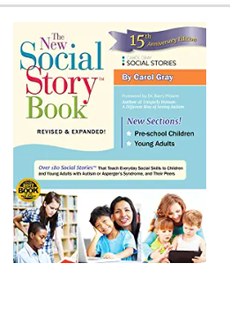
https://www.abaresources.com/social-stories/

Recommended books

The New Social Story Book- By Carol Gray

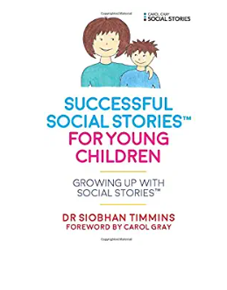

Successful Social Stories™ for Young Children with Autism: Growing Up with Social Stories- By Dr Siobhan Timmins. Foreword by Carol Gray

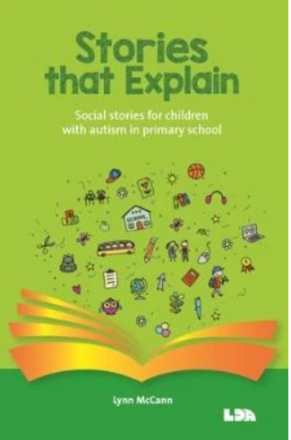
Stories that explain: Social stories for children with autism in primary school- By Lynn McCann

