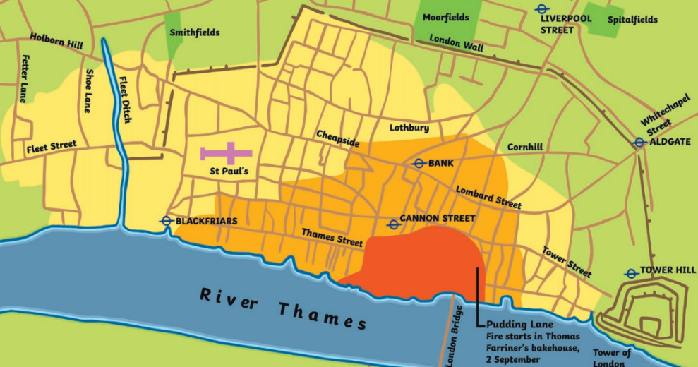
Useful Words
past present
bakery diary fire rebuilt River Thames London St Paul’s Cathedral
17th century wind

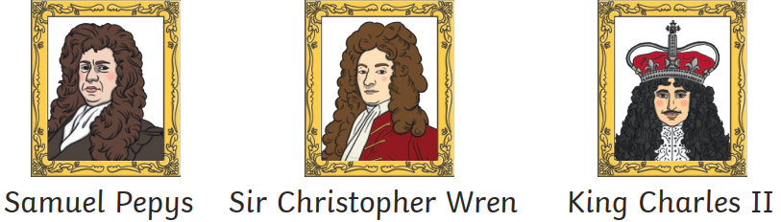
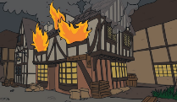
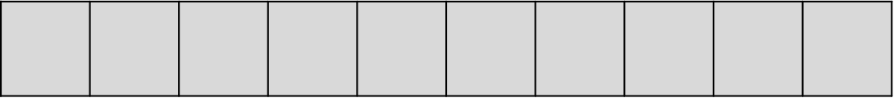
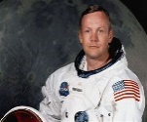
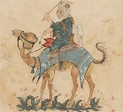
= 100 years
2023
Significant People
Timeline
Significant People
Useful Words
past present
Crimean War battlefield war First World War injuries care nurse soldiers hospital patients sick nurture nurturing

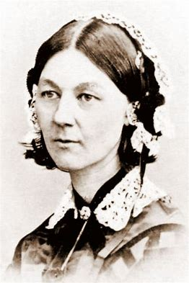
Florence Nightingale

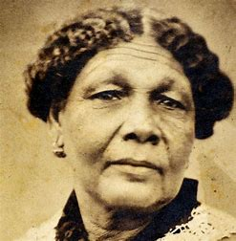
Mary Seacole

Timeline
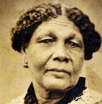
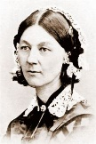
= 100 years
2023

