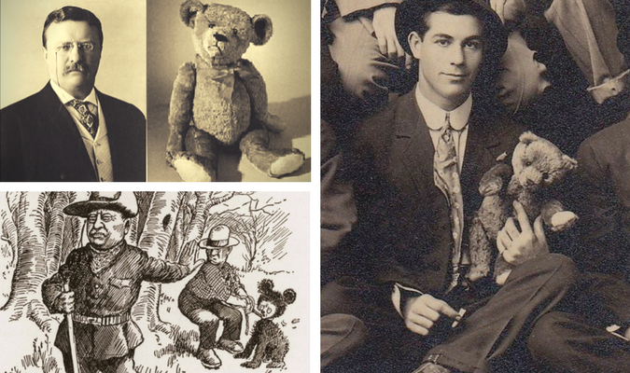
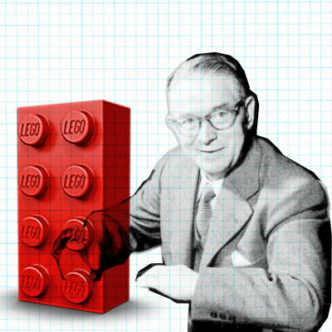
Significant People

TheodoreRoosevelt
Ole Kirk Christiansen
Useful Words
old new past present
dirty clean rusty shiny
broken fluffy scruffy
batteries electric
plastic wood fabric metal

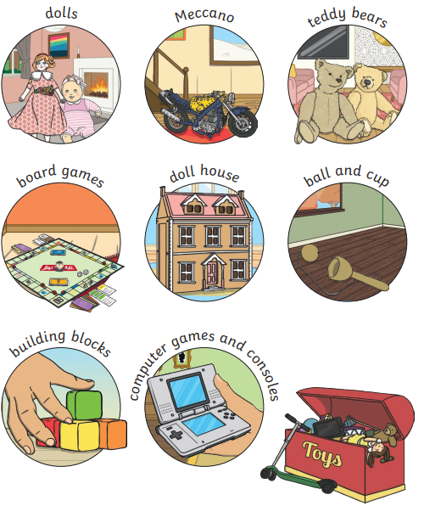

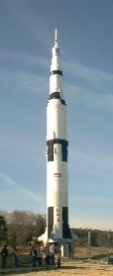
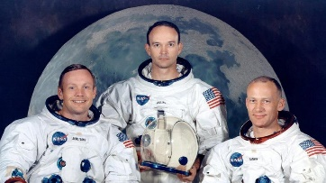
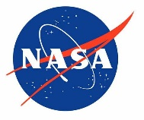
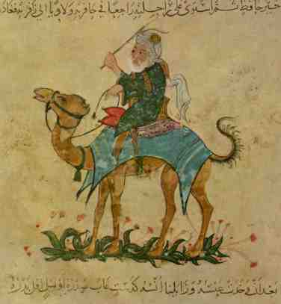
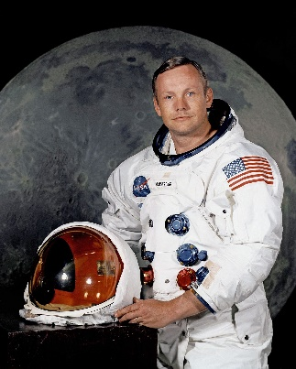
Timeline
Toys I play with
Toys my parents played with
Toys my grandparents played with
2023
Useful Words
past present explorer journey
Morocco Muslim caravan
astronaut Saturn 5

Buzz Aldrin
Michael Collins

Significant People
Ibn Battuta
Neil Armstrong

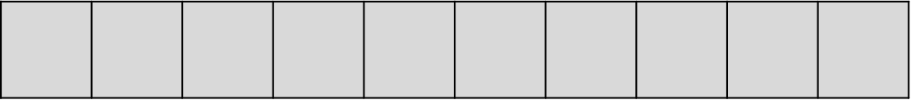
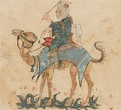
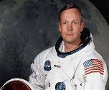
2023

= 100 years
Timeline
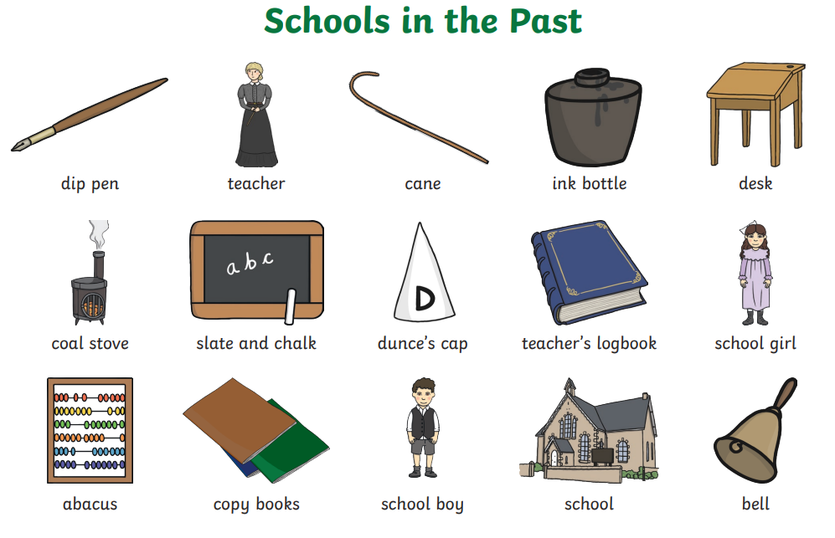
Useful Words
past present
old new
compare differences similarities
Victorian
St. Mary’s School

1845 – Old St.Mary’s School built
2000 – New St.Mary’s School built
2024
The Victorians
Me at school
My parents at school
My grandparents at school

