
COMPUTING: PROGRAMMING- Repetition in Shapes
KNOWLEDGE ORGANISER
Y4

Overview |  |  | Programming Patterns
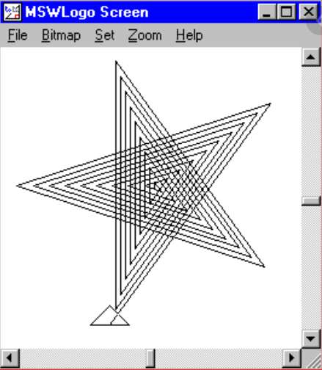  Repetition in Shapes  - Programming is when we make a set of instructions for computers to follow.  -Logo is a text-based program that we can use in order to create shapes and patterns.  -We use algorithms (a set of instructions to perform a task) which we can plan, model and test, in order to create accurate and imaginative shapes and patterns. |  |  |   -Patterns: Patterns are things that repeat in a logical way. In everyday life, patterns are everywhere!  -Patterns in Logo: Instead of typing in the code to create each individual shape, we can save time by repeating a sequence of instructions. We use the ‘repeat’ function.  -Repeat: Type the command ‘repeat’ — this repeats commands a set number of times. The number following repeat is the number of times to repeat the code, and the code to be repeated is in square brackets, e.g. repeat 4 [FD 100 LT 90]  The above code will repeat FD 100 LT 90 four times.  -Creating Shapes and Loops: To make shapes, we need to know the angles of corners of different shapes (see right). Using the repeat function with shapes can help us to make spirals.  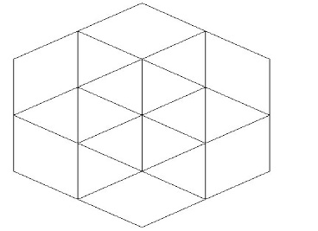  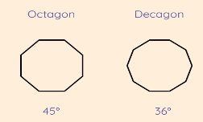  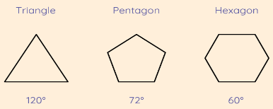
The Basics of FMS Logo
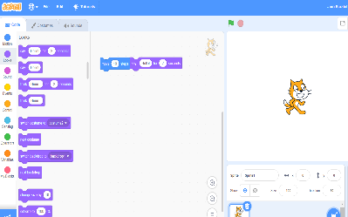
-What is FMS Logo? Logo is a text-based programming language, where we can type commands which are then drawn on the screen.
-Logo helps us to learn how to use programming language, whilst also being creative and using problem-solving skills.
 |  |  | Sequencing and Algorithms | Trialling and Debugging
 |  |  | -A sequence is a pattern or process in which one thing follows another.  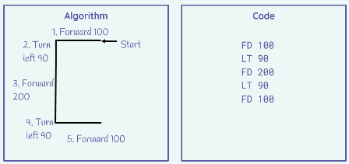  -We design algorithms (sets of instructions for performing a task) to help us program the sequence that we require to achieve our desired outcomes.  -Programming is the process of keying in the code recognized by the computer (using your algorithm). | 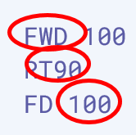  -Programmers do not put their computer programs straight to work. They trial them first to find any errors:  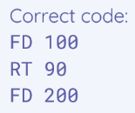  -Sequence errors: An instruction in the sequence is wrong or in the wrong place.  -Keying errors: Typing in the wrong code.  -Logical errors: Mistakes in plan/thinking.  -If your algorithm does not work correctly the first time, remember to debug it.
The Display:  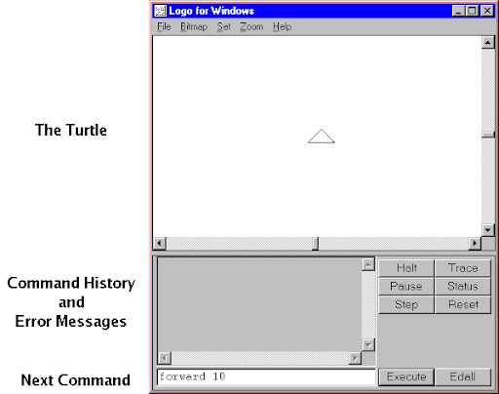 |   Basic Commands:  -FD: Forwards. Always followed by a space and the number of steps, e.g. FD 50  -BK: Backwards. As above, e.g. BK 50  -LT: Left turn. Always followed by a space and then the degrees to turn, e.g. LT 90  -RT: Right turn. As above, e.g. RT 90  -CS: Clears any pen marks on your screen and gets the turtle back to the centre.  -PU: Stops turtle from leaving a pen trail.  -PD: Makes turtle leave a pen trail again.
Important Vocabulary

commands code snippet pattern repetition repeat value trace decompose procedure

