
COMPUTING: CREATING MEDIA- Audio Editing
KNOWLEDGE ORGANISER
Y4

Overview |  |  |  | Using Software
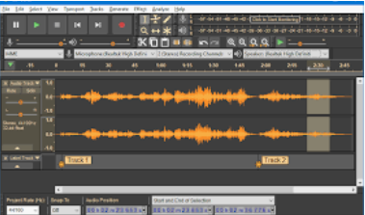  Audio Editing  -You should already know that audio means sound, including music, sound effects, and podcasts.  -The process of recording and listening to sound requires input devices (e.g. a microphone) and output devices (e.g. a speaker).  -Podcasts are a type of spoken word audio file, that can be downloaded by listeners.  -People can have ownership over audio files, and can have the audio copyrighted, so that it can’t be copied without permission.   |  |  |  | Audacity is one example of an audio editing tool, but many others are available. For example, you can use the voice memo recorder on a tablet.
 |  |  |  |   Skip to end  Play  Record  Skip to start  Pause | How to Record a New Track  1.Go to the tab ‘Tracks’ and then ‘Add New.’  2.Name the new track  3.Click in the track’s window to select it.  4.Press record to begin recording into the new track.  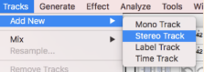  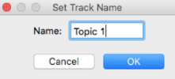  
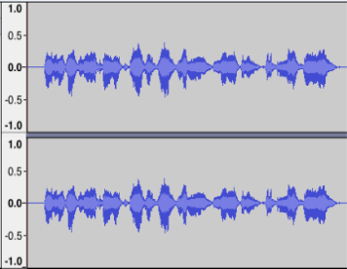
Stop
The sound is shown as a waveform. We should aim for it to peak at around 0.5/ -0.5

Input and Output Devices |  |  |  | 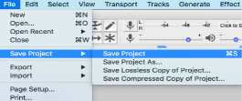  Got to the ‘file’ tab and ‘Save Project’ to save your work. You can also delete recordings, but you should only ever delete your own files!
We use input devices to send the audio to the device/ computer.
We use output devices to listen to the audio from the device/ computer.
Input Devices | Output Devices |  |  | Creating Podcasts
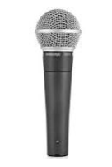  With the help of special cables, musical instruments can be linked to computers, and become input devices. | 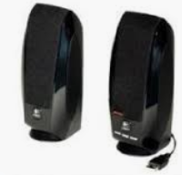  Digital speakers turn the electrical signal into an audio output that can be heard by the listener. |  |  | Podcasts are a type of spoken word file that can be downloaded by listeners. A user can often choose to download the whole series of podcasts.  Some examples of podcasts are ‘Stories Podcast’, ‘Six Minutes’ and ‘Brains On! Kids Science Podcast.’    Features of podcasts include:  Sounds: Voices, jingles, background music, sound effects  Information: Presenters’ names, name of podcast, introduction, main section, conclusion. |  | Top Tips for High-Quality Podcasts  -Speak clearly  -Avoid fillers (‘um’, ‘like’)  -Avoid coughing/ sneezing  -Take turns to speak  -Avoid background noise  -Don’t touch the microphone  -Choose music carefully
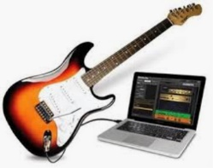  Microphones are input devices that change sound into electrical signals, which can then be recorded or transmitted. | 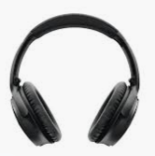 |  | Headphones are worn over the ears of the listener, so that only they can hear the sound output.
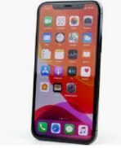
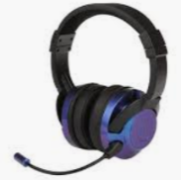
Some devices are capable of acting as both input and output devices. Examples include headsets, smartphones, and voice assistants (e.g. Google Home and Amazon Echo).
Important Vocabulary

Audio Record Playback Input Output Sound Podcast Selection Mixing Time shift Export Sound file

