
COMPUTING: DATA AND INFORMATION- Grouping Data
KNOWLEDGE ORGANISER
Y1

Overview |  |  | Grouping and Counting
  Grouping Data  - Data can be numbers, words or pictures. Information is what we can understand from looking at data.  -Objects can be labelled using either their names or describing their properties.  -Labels can be used to place objects into groups. This helps us to count and compare data easily, through looking at similarities and differences.  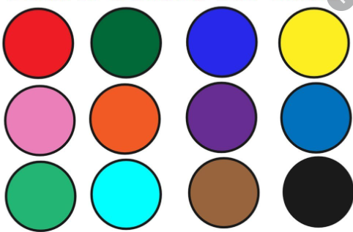 |  |  | 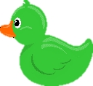  -Grouping: The same objects can be put into different groups, depending upon their properties. Computers can help us by allowing us to put different objects into groups.  -For example, a computer can be asked to group all of the pictures that have a certain name label, e.g. ‘duck’, or property, e.g. yellow.  -Counting: Computers can be programmed to count the amounts in each group.  -For example, when your teacher takes the class register, the computer program can count how many ticks and crosses there are, to tell the teacher how many children are in school.    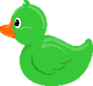    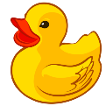  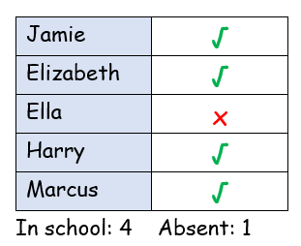
Labels and Properties

-Labelling: Labels are all around us!

-Labels are the names that we give to things so that we can easily identify them.

-On computers, we can label different objects so that the computer knows what they are.
 |  |  | Comparing | Answering Questions
 |  |  | -Comparing is when we look at what is similar (the same) and what is different between objects. You can compare objects or groups of objects.  Examples of comparing words  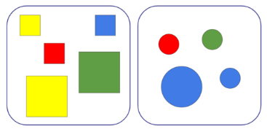  -more than, less than, the same as, least, most, bigger, smaller, older, younger, longer, shorter, wider, thinner. | -Objects can be grouped in order to answer questions and solve problems.    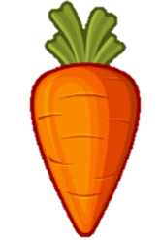  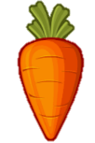  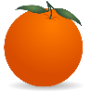  -For example, if asked how many orange items there are below, you could group them into ‘orange’ and ‘not orange.’ To find out if there is more fruit than vegetables, you could group them into ‘fruit’ and ‘vegetables.’    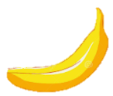  
-Properties: Objects have different properties (features) that we can choose to label them by.  -Some examples of the properties of an object include its size, its colour and shape.  -We can use properties to tell computers what objects are and how to sort them. | -Describing: Objects can be described by their name labels and their properties.  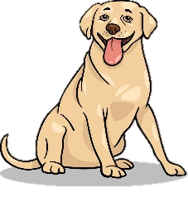  -E.g. the picture here could be correctly labelled as ‘dog’, ‘Labrador’ or ‘animal.’  Use describing adjectives for accuracy, e.g. big, circular, blue, old, thin, long, heavy etc.

Important Vocabulary
Most/fewest/least
The same
Object
Label
More/less
Data
Value
Shape
Size
Colour
Properties
Image
Search
Group

