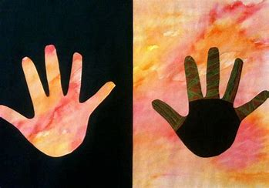
Positive and negative handprints
Key Words
Charcoal
Composition
Negative image
Pigment
Positive image
Pre-historic
Proportion
Scaled up sketch
Smudging
Texture
Tone



Primary colours
Secondary colours
Stone Age Art
Stone age paintings were produced approximately 17,000 years ago, before there were any houses, buildings, roads, cars, electricity or schools. They were painted on the walls of caves. Caves are dark, so the artists would have needed oil lamps made from stone and animal fat. For the people of this time, wild animals were a primary source of food and were very important.
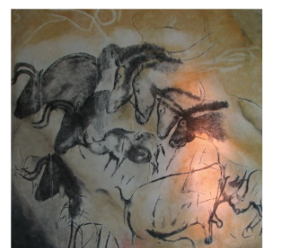
Key Words
Shade
Tone
Light
Dark
Hatching
Texture
Shape
Proportion

Sections of an animal’s body

Sketching
Mark making is a term used to describe the different lines, patterns and textures we can create.
How many different lines can you make?

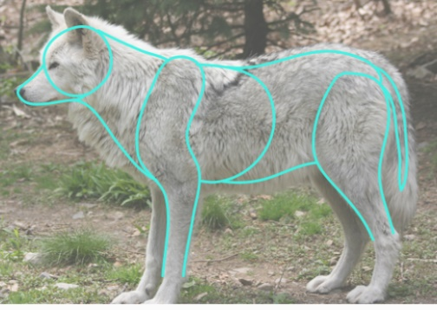

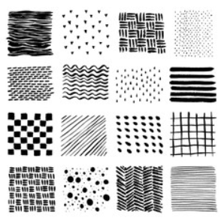
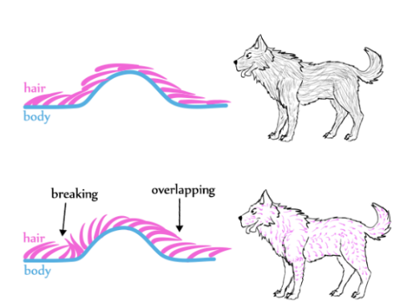
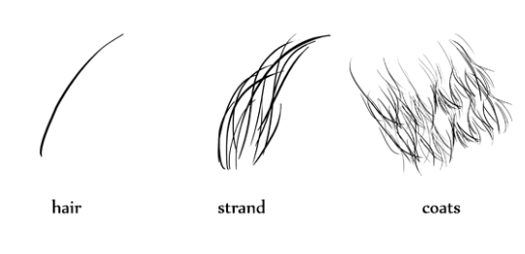
Representing fur

How fur lays on an animal’s body

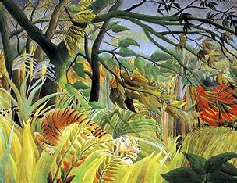
Henri Rousseau

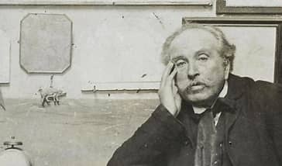

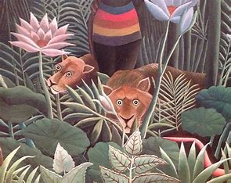
Henri Rousseau was a French post impressionist artist born in France in 1844.
He painted richly coloured and detailed jungle scenes, although he never left France!
He was admired by Pablo Picasso and other modern artists.

