Observational drawing
Key Words
Thick
Thin
Soft
Hard
Broad
Narrow
Fine
Pattern
Line
Shape
Outline
Detail
Texture
Mark Making
Building
Architecture

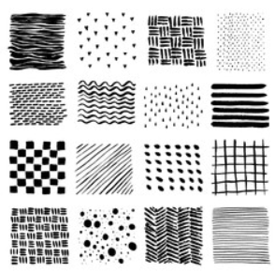
Sketching Famous Buildings
Mark making

Remember to
Look
Look
Look
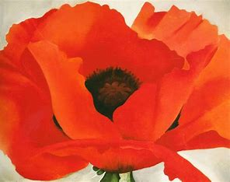
Key Words
Watercolour paints
Wet on wet technique
Primary and secondary colours
Colour mixing
Artist study – Georgia O’Keefe
Born in 1887, Georgia O'Keeffe was an American artist who painted nature in a way that showed how it made her feel. She is best known for her paintings of flowers and desert landscapes.
She played an important part in the development of modern art in America. She had a unique and new way of painting nature, simplifying its shapes and forms meant that she was called a pioneer.

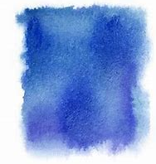
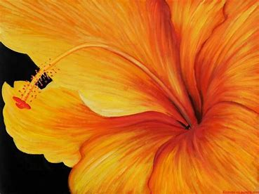
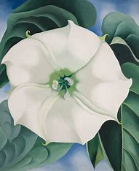
Wet on Wet technique
Apply water to paper first then colour.

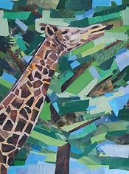
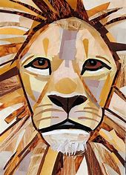
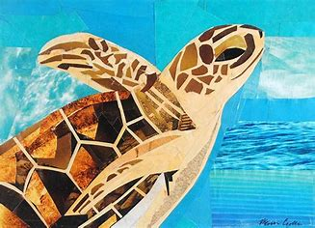

Artist study -
Megan Coyle
Megan Coyle is an American artist who create collage entirely from magazine strips.
Key Words
Collage
Tear
Stick
Arrange
Composition
Proportion

