Observational drawing
Key Words
Thick
Thin
Soft
Hard
Broad
Narrow
Fine
Pattern
Line
Shape
Outline
Detail
Colour
Texture
Nature
Mark Making

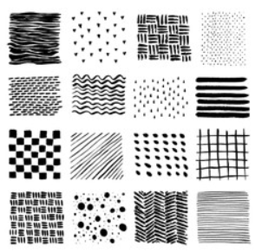
Remember to
Look
Look
Look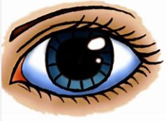
Sketching
Mark making is a term used to describe the different lines, patterns and textures we can create.
How many different lines can you make?


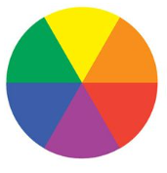
Key Words
Primary (colour)
Secondary (colour) Light
Dark
Thick
Thin
Tone
Colour mixing
Warm
Cold
Shade

Mondrian
The colour wheel
Primary colours
Secondary colours

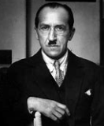
Colour Mixing
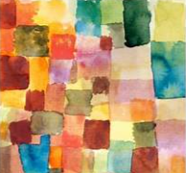
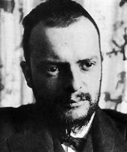
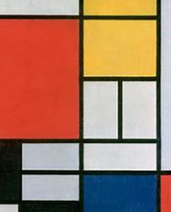
Tone = adding white
Shade = adding brown
Paul Klee

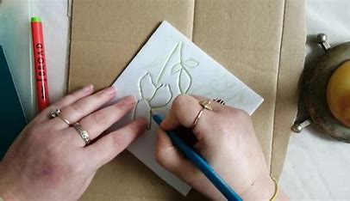
Step 1 Draw image
Animal themed art – Combining sketching, watercolour painting and printing.

Key Words
Print
Polystyrene block
Tile
Roler
Ink
Duplicate
Repeat
Outline
Image

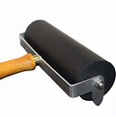
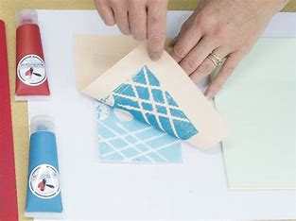

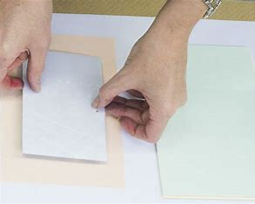
Step 2 Apply ink to tile

Step 4 Reveal image
Step 3 Apply pressure with dry roller

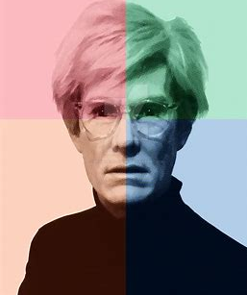
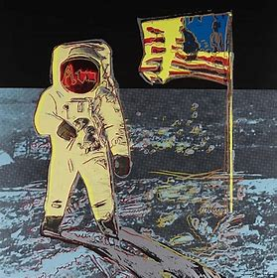
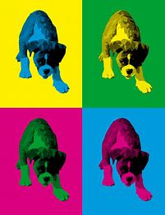
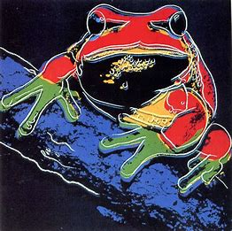
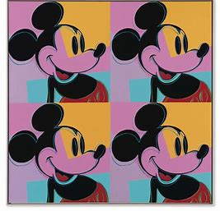
Andy Warhol
Andy Warhol was part of the pop art movement. He was born in 1928 in Pennsylvania. His parents were from a part of Europe that is now part of Slovakia. They moved to New York in the 1920s.
His first job was illustrating adverts in fashion magazines. Now is he known as one of the most influential artists who ever lived! Pop art is about making art inspired by things from popular culture.

Pop Art

